Readme

The reinforcement learning script (RLS) is a tool to assist in automated calibration of VELMA models. This readme document describes the theory behind RLS and provides instructions on its usage.

Theory

A diagram of the RLS strategy is shown in Figure 1.

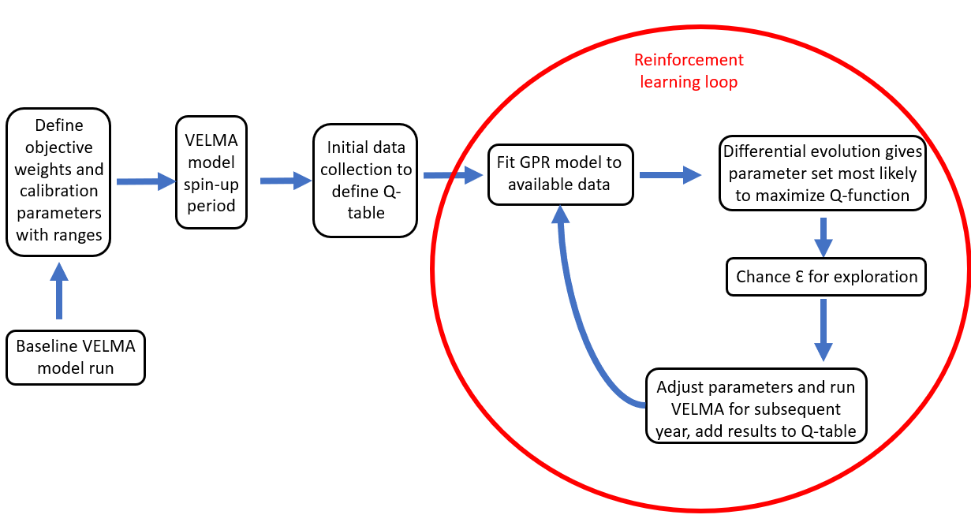
Figure 1: Schematic of reinforcement learning strategy.

The objective function can be thought of as the reward function or Q-function. The Q-function for VELMA calibration, defined in Equation 1, is the increase in the multi-objective weighted statistic from the baseline value.

Equation 1: $Q={MOWS}_{new}-{MOWS}_{base}$

The multi-objective weighted statistic is defined in Equation 2. The statistics of interest to the VELMA model calibration are the total simulated to observed annual ratio (TSOAR), summertime simulated to observed annual ratio (SSOAR), coefficient of determination R², and Nash-Sutcliffe efficiency (NSE). TSOAR and SSOAR are important for matching the annual load of the variable of interest, regardless of the timing. VELMA has been known to under-predict late summertime low flow, so restricting the SOAR to the summer months can be important for a better prediction. R² and NSE reflect the timing of delivery in addition to the magnitude. The weights of each statistic can be edited by the user. Appropriate weights depend on project goals and any known calibration issues that should be targeted in the study area.

Equation 2: $MOWS=\frac{ w_{1}TSOAR+w_{2}SSOAR+w_{3}NSE+w_{4}R^{2}}{\sum_{n=1}^{4}{}w_{n}}$

The statistics of interest TSOAR, SSOAR, NSE, and R² are calculated using a comparison between simulated and observed data. The observed data can match any of the data reported in the VELMA results. The equations for each statistic are given in Equations 3 through 6. All statistics are calculated to force the values between zero and one, where zero is worse and one is a perfect fit. Summertime values are filtered using the months June through September.

Equation 3: $TSOAR=1-|1-\frac{\sum_{i=1}^{N}{}Q_{sim, i}}{\sum_{i=1}^{N}{}Q_{obs, i}}|$

Equation 4: $SSOAR=1-|1-\frac{\sum_{i=1}^{N}{}Q_{sim, summer, i}}{\sum_{i=1}^{N}{}Q_{obs, summer, i}}|$

Equation 5: $NSE=max(0, 1-\frac{\sum_{i=1}^{N}{}{(O_{i}-S_{i})}^{2}}{\sum_{i=1}^{N}{}{(O_{i}-\underline{O})}^{2}})$

Equation 6: $R^{2}=1-\frac{{\sum_{i=1}^{N}{}({\hat{Y}}_{i}-\underline{Y})}^{2}}{{\sum_{i=1}^{N}{}Y_{i}-\underline{Y})}^{2}}$

The solution space is also informed by expert knowledge. Unlike previous studies which commonly used global or local sensitivity analyses to select parameters, the user is expected to select appropriate parameters that have physically realistic ranges and which are influential for the calibration data. Any VELMA parameter can technically be selected for calibration, so domain knowledge and an understanding of the VELMA model is required for effective parameter selection.

After setting objective weights and specifying calibration parameters with ranges, the VELMA simulation and calibration process begins. There is a “spin-up” period, which is generally three years, in which no data is collected. The spin-up period is required to instantiate heterogeneous water volumes across the landscape. If there is not enough data in the Q-table to define the Gaussian process regression model, then the algorithm begins with a data collection period, selecting random parameter values within the defined ranges. The number of data points in the initial data collection period can be defined by the user. After spin-up and initial data collection, a Gaussian process regression model is fitted to the available data to estimate the function f(P) = Q, where P is the input parameter matrix and Q is the reward. Each year varies in its climate drivers, so the data collected is expected to be noisy as some parameter sets will produce a better reward depending on the climate conditions.

GPR models are a non-parametric machine learning technique that can be used for regression problems. They are well-suited for relatively low-dimensional spaces (less than a few dozen features) compared to other methods such as neural networks and provide probabilistic predictions, including confidence intervals. The GPR model requires a prior distribution, which can be specified using a kernel function for the covariance. The choice of kernel is consequential for the resulting GPR model and the best kernel depends on the problem at hand. The GPR model is implemented using the Python scikit-learn package.

Differential evolution is used to predict the parameters that will most likely maximize the objective function. Differential evolution is an evolutionary algorithm that can be applied using the Python scipy package. It is a stochastic method that evaluates populations for the highest reward, and uses evolutionary principles of fitness, crossover, and random mutation to provide a prediction of the parameter set with the best performance.

An ε-greedy algorithm is used to enable further exploration of the solution space during the simulation and avoid getting trapped in local maxima. The user is able to specify epsilon (the rate of exploration).

Application
The files required to run RLS are the main file, reinforcement_learner.py, and the supporting imported functions in the rls_functions.py file. Optionally, resample.py and divide_catchments.py can be used to downscale and parallelize downscaled model runs, which can speed model runtime considerably.

The user will edit parameters in the main file, reinforcement_learner.py, to suit their application before running the RLS. Every variable below the import statements and above the line labeled “Do not edit anything below this line” should be edited by the user. The following information describes each user-editable parameter in more detail.

start_year: integer, year that the model spin-up starts
start_learning_year: integer, year that the model calibration starts
end_year: integer, year that the model ends
allocated_memory: string, describes how much memory each process will use while running VELMA
jar_path: string, file path to the VELMA jar file
working_directory: string, folder path to your working directory
xml_name: string, name of your VELMA model set-up file (don’t include the .xml extension).
xml_path: string, do not edit; set up your working directory so this line works as-is
calibration_results_path: string, folder path where the calibration results should write. Set up your .xml file so the results are also written here.
log_file_name: string, name of the log file which should be descriptive
default_path: string, file path to a DailyResults.csv file which was the result of the baseline model run
calibration_data: string, describes the data you are calibrating and must exactly match a column name in the DailyResults.csv file
start_obs_data_year: integer, year that the observed data starts in
observed_file: string, file path pointing to the observed data file
n_years_per_point: integer, number of years that constitute a data point in the GPR
n_data_points: integer, number of total data points the RLS should collect to complete
n_initial_exploration: integer, number of data points to collect in the initial exploration period
epsilon: float, rate of random exploration as a decimal
soar_weight: float, weight of TSOAR in the multi-objective weighted statistic
nse_weight: float, weight of NSE in the multi-objective weighted statistic
summer_soar_weight: float, weight of SSOAR in the multi-objective weighted statistic
r2_weight: float, weight of R² in the multi-objective weighted statistic
velma_parallel: boolean, runs VELMA in parallel mode if True and in solo mode if False
max_processes: string, number of processes to run simultaneously in VELMA parallel mode
outlet_id: string, ID of outlet to use for results folder if using VELMA parallel
downscaling: boolean, downscales the VELMA model if True and uses original resolution if False
downscaling_factor: integer, downscaling factor to use if downscaling
divide_catchments_flag: boolean, user does not need to edit this variable
number_catchments: integer, number of catchments to divide if downscaling and using parallel mode
crs: string, defines coordinate reference system
velma_parameters: dictionary that defines the parameters to adjust during calibration and their allowable ranges. Each entry should contain the actual variable name in VELMA along with 1) a descriptive name for output files, 2) the default / baseline value, 3) the minimum allowable value and 4) the maximum allowable value.

